Experiment 2: Library Book Reservation System
Aim
To design and develop a Library Book Reservation System using Zoho Creator, a cloud-based SaaS platform, that enables students to reserve books online, maintain reservation records, and manage book availability efficiently.
Procedure
Step 1:
Log in to Zoho Creator using your account.
Step 2:
Click Create New Application.
Step 3:
Enter the application name as: Library Book Reservation System
Step 4:
Create a form named: Book Reservation
Step 5:
Add the following fields:
Field Name | Field Type
Student Name | Single Line
Student ID | Number
Book Title | Single Line
Author | Single Line
Book Category | Drop Down
Reservation Date | Date
Return Date | Date
Number of Books | Number
Fine | Currency
Reservation Status | Drop Down
Book Status | Drop Down

Step 6:
Configure the drop-down values.
Book Category
- Fiction
- Non-Fiction
- Science
- Technology
- History
- Biography
Reservation Status
- Pending
- Approved
- Rejected
Book Status
- Available
- Reserved
- Issued
Step 7:
Create workflows to validate user inputs, such as ensuring the return date is after the reservation date and calculating fines if applicable.
if(input.Number_Of_Book != null)
{
input.Fine = 0;
}
input.Book_Status = "Reserved";
alert "📚 Book Reserved Successfully!" + "\n\nReservation ID : " + input.Reservation_Status + "\nStudent Name : " + input.Student_Name + "\nBook Title : " + input.Book_Title + "\nBook Status : " + input.Book_Status + "\nReservation Date : " + input.Reservation_Date;
Step 8:
Create a Book Reservation Report to display all reservation records.
Step 9:
Test the application by entering sample student and book details and verify that the reservation is successfully recorded.
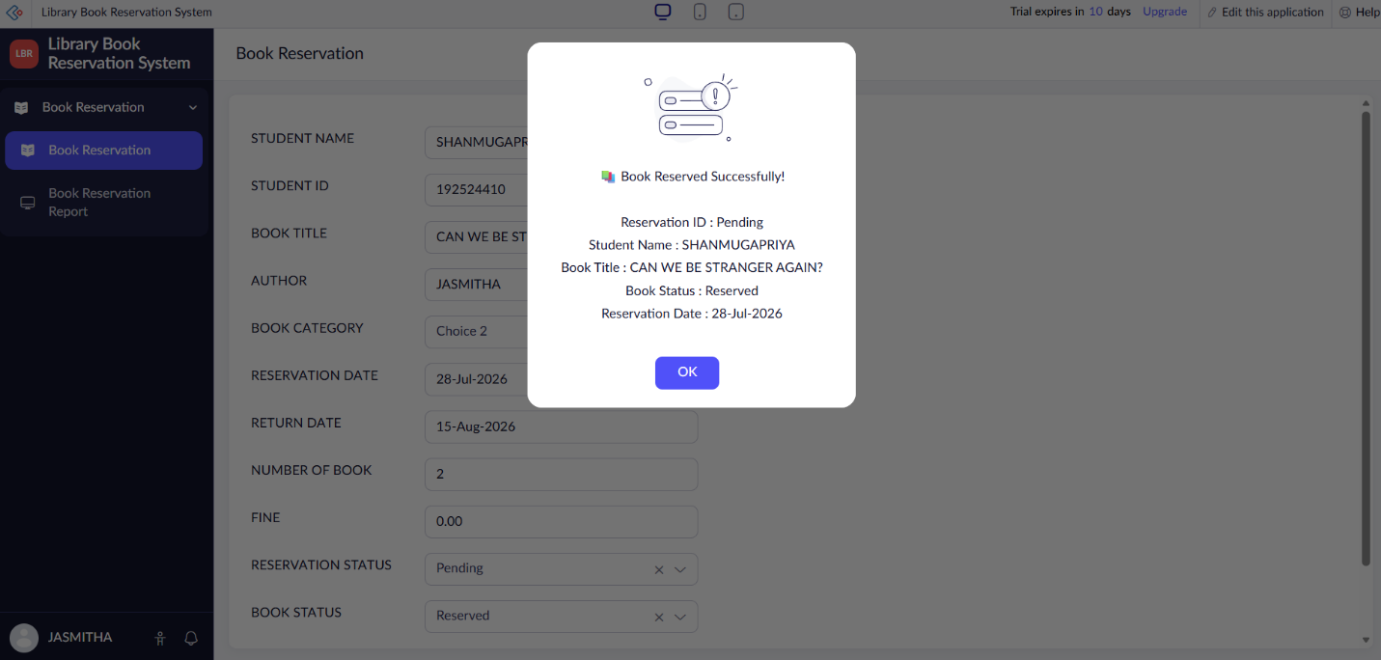
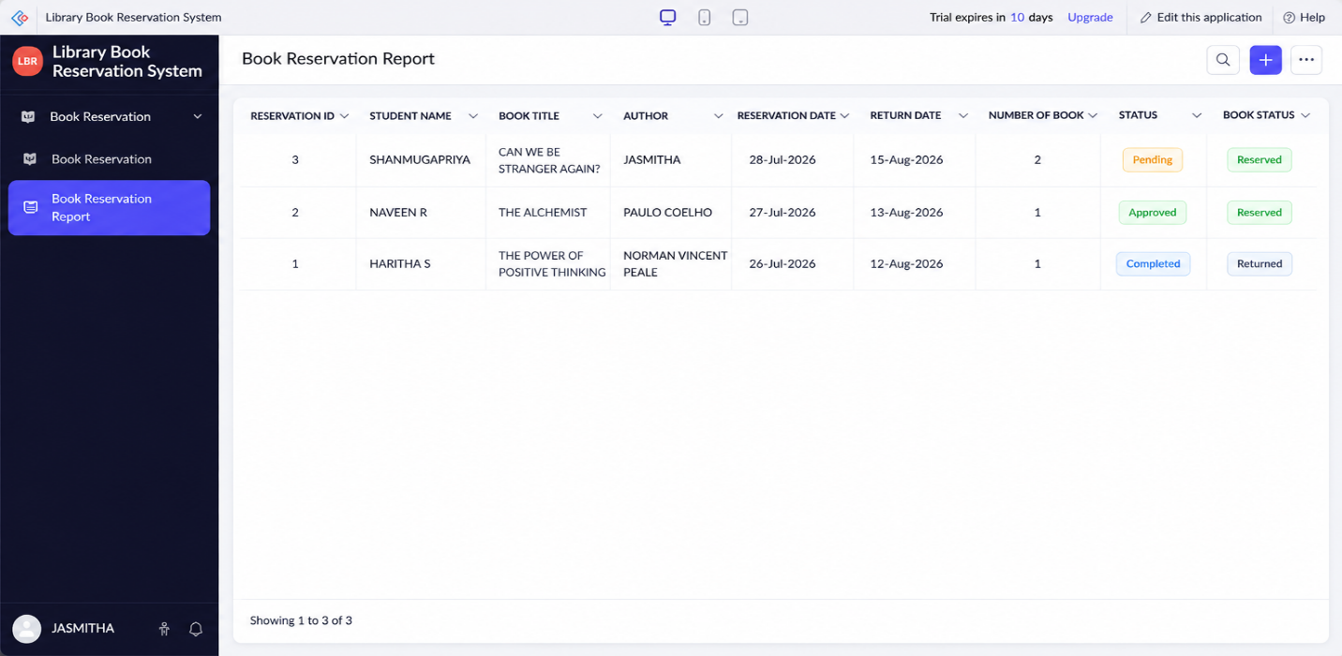

Implementation
The Library Book Reservation System was implemented using Zoho Creator forms, workflows, and reports. The system allows students to reserve books by entering their details, book information, reservation date, and return date. The reservation status and book status are automatically updated based on the reservation process. After the reservation is successfully submitted, a confirmation message displaying the reservation details is shown to the user. Reports are generated to manage and monitor all book reservation records efficiently through the cloud platform.

